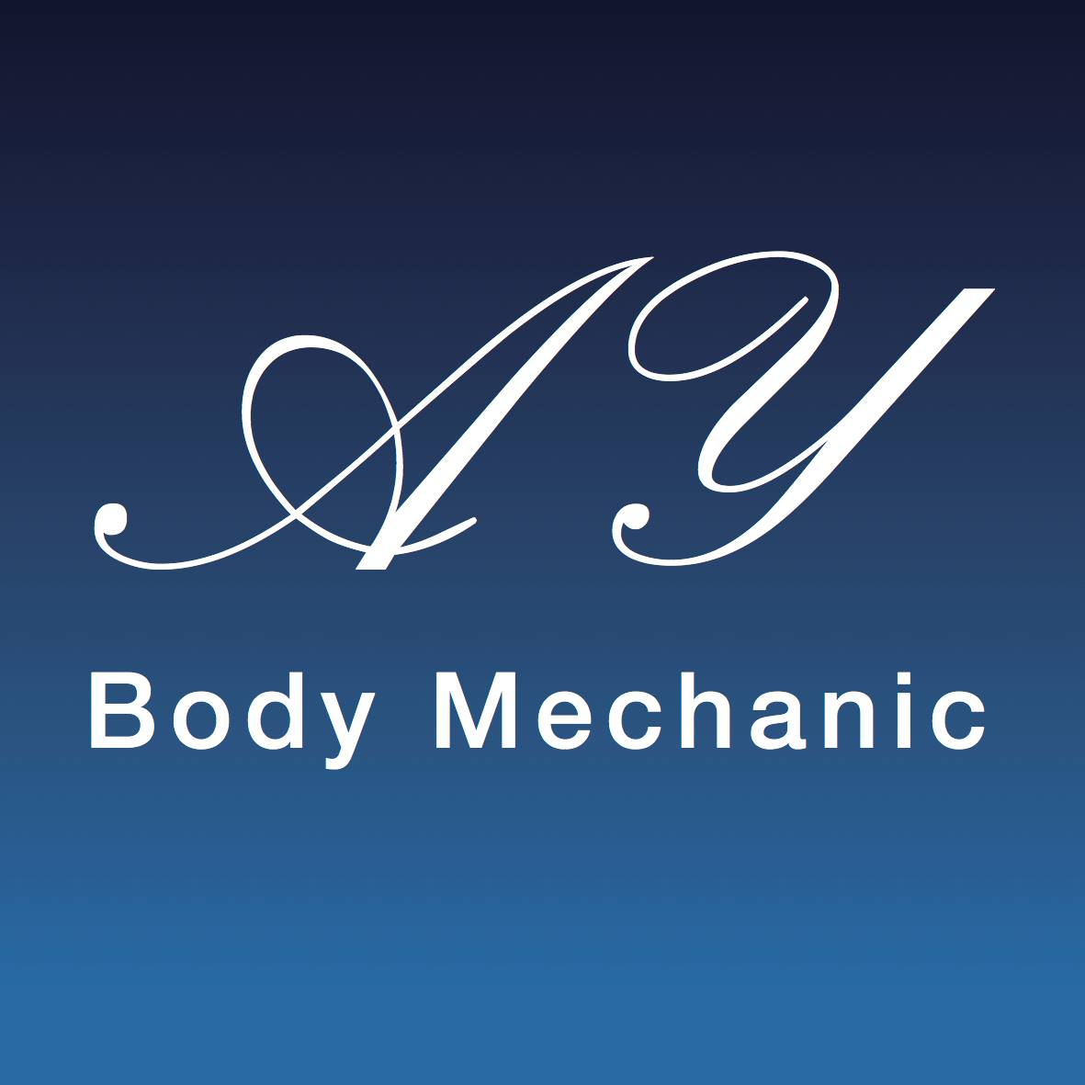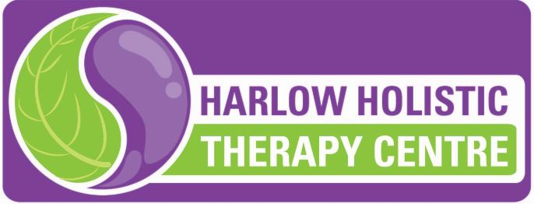

Coronavirus (COVID-19) Infection Prevention and Control Risk assessment procedure
Version 2

This document is in alignment with the Harlow Holistic Therapy Centre

This policy will reflect AYBodymechanic’s therapy approach to Coronavirus (COVID-19) Infection Prevention and Control as well as the actual procedures which are in place; it will be regularly reviewed and updated in line with Government Guidance and local Health authorities. I have made changes to working practices to make your treatment feel safe, comfortable whilst also receiving the benefit of having an enjoyable treatment. As always, your safety is my concern and these practices will provide you with the assurance that you are in safe hands. These will be in place until we can return to full normality. I have missed being able to offer you treatments and really look forward to welcoming you back soon.

Prior to re-opening I have implemented a number of changes which I would like to make you aware of, the facility has had a deep and full clean. Many items have been removed to ensure that surfaces are clean and tidy and easy to wipe down. During the time I have been closed I have completed the Coronavirus (COVID-19) Health, Safety & Hygiene returning to work course which is accredited by the Federation of Holistic Therapy along with guidance from the Association of Physical Natural Therapists. There are a few changes in the way that I operate that you will notice when you next visit.

You will receive a health questionnaire via email which needs to be completed and sent back before each appointment. You will need to complete a new client consultation form which will be emailed and due to the sensitivity of the information you can complete this sign and bring it with you or if preferred information can be taken via phone. This is to ensure that all your personal information is up to date.

Booking Appointments

If I feel ill or have symptoms of C0VlD-19, I will self-isolate immediately. This may mean that I have to cancel your appointment at short notice. I appreciate that this may be inconvenient, but it is done entirely for your own safety. If you or any of the people you live with feel ill or display any symptoms of C0VlD-19 – please advise me as soon as possible before attending your appointment. You will not be charged for any appointments which you miss due to Covid-19 or symptoms relating to it.

Arrival times and facility information

For your safety I ask that you attend your appointments as close to the appointment time as possible. Please do not turn up early for appointments as this may mean that you come into contact with other clients. I have increased the frequency of cleaning, including making sure those common surfaces such as toilets door handles, taps etc. are wiped clean using disinfectant products between each client.

As usual all tools and equipment will be disinfected or sterilised in line with the specific manufacturers’ instructions for your safety. Wherever possible I will utilise single use items during a treatment that will be disposed of safely after use in order to protect you from cross infection. You will have access to soap and hot water to wash your hands or you can use hand sanitiser as soon as you enter the facility.
I will be using personal protective equipment (PPE) during your visit and during your treatment including facemask or visor and an apron. I can confirm that the laundering of towels and my uniform is a priority I can assure you that all salon laundry is washed at 60 degrees C. All disposable items are bagged and safely removed from the treatment area between each client. I have removed magazines, cushions and unnecessary decorations etc. The container for client’s clothes and possessions will be disinfected between appointments. Laundry will be placed in a black bag and tied until it is washed.
Windows where possible will be open and the doors will have a sufficient gap to allow airflow into the room whilst not compromising your modesty and in between clients will be left open to recirculate the air. A cleaning checklist will be placed in the facility signed and dated daily.
I have carried out a risk assessment on all of the treatments that I offer and am confident that I can continue to provide these safely. The following is a result of the risk assessment.

The therapist - I will wear a visor or mask and apron at all times. Hand washing and sanitisation practices will enable hands on treatment without the use of gloves. A consultation form will be emailed prior to the appointment which can be emailed back or brought with you when you attend your appointment. If you forget your form, I will complete the consultation adhering to the social distancing rules and will sign disclaimers on your behalf if you do not have your own pen. Where possible the use of paper will be avoided. Online consultations will be offered to reduce the contact time where possible.

Clients - Please can you were a mask on entering the premises, please bring your own mask where possible, I will have a small supply in case you forget. If you have a ‘mask exemption card ‘ please can you let me know prior to your appointment. Please can you bring your own water. On arrival I will provide you with a container for your personal items, including your clothes. I will ask you to enter the treatment room, remove necessary clothes and lay on the massage couch before I enter the room. For clients with disabilities who may need help getting onto the couch I will be able to assist. I will then enter the room and conduct your treatment.

Couch management - Wipeable covers will be used on the massage couch, pillows along with disposable face hole covers . Laundered towels, blankets and disposable covers will be used for each client. Oils will be decanted to different vessel to avoid cross contamination and these will be disinfected between clients

Musculoskeletal treatments:

Please note that the following is a guide and will change when the social distance measures have been lifted. Note if treatments can be conducted with client laying face down this will be applied, if not then with the client laying on their side and Supine only when other positions are not possible this will be at the discretion of the therapist. Hot stones, Ultrasound and Intrasound equipment will be disinfected as per manufactures instructions.

Treatment times will be kept succinct and treatment duration will be focused on what is necessary to achieve the result to keep contact to what has been deemed necessary.

- Massage to back, neck and shoulders will be conducted with client face down the client will not need to wear a mask.
- Indian Head massage to be conducted with the client facing away from the therapist and the client to wear a mask.
- Facial, neck and shoulder treatment with the client face up can be applied providing client wears a mask.
- Leg massage and foot treatment - when the client is laying face down, they do not need to wear a mask, but when supine then facemask can be worn.
- Posture and Body-use evaluation facemask can be worn by client
- Mobilisation, distraction, manipulation or mechanical therapy facemask can be worn by client if they are ‘face up’
- Mind health or nutritional therapies will be conducted either face to face using the social distancing measures or can be conducted online. The therapist will wear a facemask or a visor.
- Remedial exercise the client can wear a mask as corrections may be needed within the social distancing measures.

Any advice, exercise sheets or handouts will be emailed to the client

3o minutes will be left in between clients to ensure sterilisation and preparation for the next client. I understand the importance of hand hygiene and I will ensure that I wash my hands in accordance before the start of your treatment. I will make sure your treatment is safe and comfortable whilst being an enjoyable experience for you.

Booking process
- Email the Covid 19 pre-screen health check list
- Email the client consultation form
- Review information and then confirm appointment
- Book in pre-appointment consultation (10 mins) the day before the appointment to confirm no symptoms and go through the Covid RA sections relevant to them
- Appointment duration to be kept to a minimum (45 minutes hands on treatment only)
- The Covid-19 pre-screen health check list to be emailed and checked before ‘all’ appointments.
- Clients that fall into the ‘higher risk areas’ will be risk assessed then if deemed essential will be treated with the client taking full responsibility for their treatment, if this applies I will use a medical grade mask. A ‘high risk’ form will be sent following the Pre-Covid health screen to confirm the clients agreement to treatment.

Nb. If client is unable to access a computer details will be taken over the phone and signature taken on arrival. The reduction of ‘hands on treatment will mitigate the risk to the client and the therapist and comply with government recommendations

Payment

You can pay by card or bank transfer. If you prefer to pay using cash please can you bring the correct amount in an envelope or we can provide the envelope for you.

All of these procedures have been implemented for yours and my safety. I will continue to take advice from the Government and the NHS regarding safe practice and will amend them as necessary.
A copy of this document will be placed inside the treatment room.

I will text you 7 days after your treatment to check if you are Ok and if you have any symptoms.

Thank you for your understanding and really look forward to welcoming you back.

AY Bodymechanic and the HHTC

Date

Signature:

