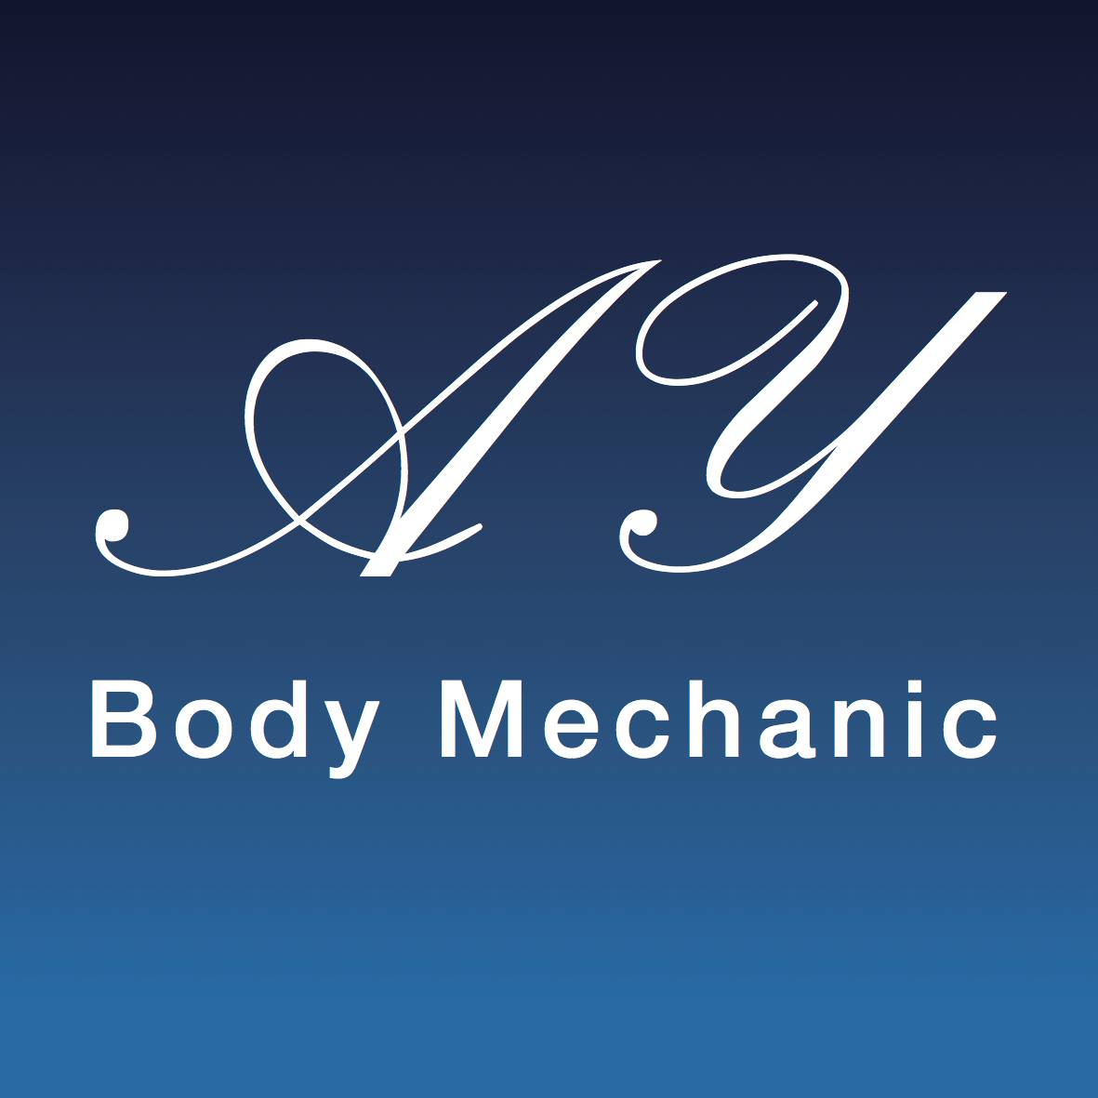

AYBM Coronavirus (COVID-19) Infection Prevention and Control Risk Assessment Procedure for Mobile Therapy Work

This policy will reflect AYBodymechanic’s therapy approach to Coronavirus (COVID-19) Infection Prevention and Control as well as the actual procedures which are in place; it will be regularly reviewed and updated in line with Government Guidance and local Health authorities. I have made changes to working practices to make your treatment feel safe, comfortable whilst also receiving the benefit of having an enjoyable treatment. As always, your safety is my concern and these practices will provide you with the assurance that you are in safe hands. These will be in place until we can return to full normality. I have missed being able to offer you treatments and really look forward to welcoming you back soon.

Prior to re starting mobile therapy work I have implemented a number of changes which I would like to make you aware of all of the equipment and laundry that will be brought into your home will be fully cleaned and sterilised before and after your visit. I will only bring the equipment deemed necessary and this will be discussed with you prior to your appointment, for example if you require a back massage your own chair will be used. During the time I have been closed I have completed the Coronavirus (COVID-19) Health, Safety & Hygiene returning to work course which is accredited by the Federation of Holistic Therapy along with guidance from the Association of Physical Natural Therapists. There are a few changes in the way that I operate that you will notice when I visit you next, again these will be discussed prior to my visit.

You will receive a health questionnaire via email which needs to be completed and sent back before each and every appointment. You will need to complete a new client consultation form which will be emailed the system used is fully encrypted for your safety and to comply with ICO data protection regulations. If preferred information can be taken via phone. This is to ensure that all your personal information is up to date.

Booking Appointments

If I feel ill or have symptoms of C0VlD-19, I will self-isolate immediately. This may mean that I have to cancel your appointment at short notice. I appreciate that this may be inconvenient, but it is done entirely for your own safety. If you or any of the people you live with feel ill or display any symptoms of C0VlD-19 – please advise me as soon as possible before attending your appointment. You will not be charged for any appointments which you miss due to Covid-19 or symptoms relating to it. I will not be able to visit in a household which is isolating because one or more family members has symptoms.

Arrival times and information

I will attend appointments as close to the appointment time as possible. All items that are brought into your house will be wiped clean using disinfectant products.
As usual all tools and equipment or surfaces I come into contact with, will be disinfected or sterilised in line with the specific manufacturers’ instructions for your safety. Wherever possible I will utilise single use items during a treatment that will be disposed of safely after use in order to protect you from cross infection. I will need access to soap and hot water to wash my hands or will use hand sanitiser as soon as I enter your home. If I need to use your bathroom, I will use of hand sanitiser and clean the area I have been in contact with. Where possible I will not sit on furniture unless the therapy requires me to do so and, in this case, I will use a towel to cover the chair. I will change my clothes between home visits. My hands will be thoroughly sanitised after before and after removing face coverings, laundry or equipment.
I will be using personal protective equipment (PPE) during your visit and during your treatment including facemask, visor and an apron. I can confirm that the laundering of towels and my uniform is a priority I can assure you that all salon laundry is washed at 60 degrees C. All disposable items are bagged and safely removed from your home. Please can you clear space within your home to ensure the area is workable especially for treatments which will require the mobile couch. Laundry will be placed in a black bag and tied on removal from your home
Windows where possible will be open and the doors will have a sufficient gap to allow airflow into the room whilst not compromising your modesty.
I have carried out a risk assessment on all of the treatments that I offer and am confident that I can continue to provide these safely. The following is a result of the risk assessment.

The therapist - I will wear a visor or mask and apron at all times. Hand washing and sanitisation practices will enable hands on treatment without the use of gloves. A Pre-covid and consultation form will be emailed prior to the appointment. If you forget your form or unable to use technology, I will complete the consultation adhering to the social distancing rules and will sign disclaimers on your behalf if you do not have your own pen. Where possible the use of paper will be avoided. Online consultations will be offered to reduce the contact time where possible.

Clients - Please can you were a mask when I arrive at your property. Please can you wash your hands when I arrive for your treatment. I will have a small supply in case you don’t have one. On arrival I will go directly to the room where the treatment will be carried out. Please can you ensure that I am not put at potential risk; this includes minimising any requirement for myself to touch surfaces, and ensuring that, as far as possible, no one else in the building comes into contact with myself.

Couch management - Wipeable covers will be used on the massage couch, pillows along with disposable face hole covers . Laundered towels, blankets and disposable covers will be used for each client. Oils will be decanted to different vessel to avoid cross contamination and these will be disinfected between clients

Musculoskeletal treatments:

Please note that the following is a guide and will change when the social distance measures have been lifted. Note if treatments can be conducted with client lying face down this will be applied, if not then with the client laying on their side and Supine only when other positions are not possible this will be at the discretion of the therapist. Hot stones, Ultrasound and Intrasound equipment will be disinfected as per manufactures instructions.

Treatment times will be kept succinct and treatment duration will be focused on what is necessary to achieve the result to keep contact to what has been deemed necessary.

- Massage to back, neck and shoulders will be conducted with client face down the client will not need to wear a mask.
- Indian Head massage to be conducted with the client facing away from the therapist and the client to wear a mask.
- Facial, neck and shoulder treatment with the client face up can be applied providing client wears a mask.
- Leg massage and foot treatment - when the client is lying face down, they do not need to wear a mask, but when supine then facemask can be worn.
- Posture and Body-use evaluation facemask can be worn by client
- Mobilisation, distraction, manipulation or mechanical therapy facemask can be worn by client if they are ‘face up’
- Mind health or nutritional therapies will be conducted either face to face using the social distancing measures or can be conducted online. The therapist will wear a facemask or a visor.
- Remedial exercise the client can wear a mask as corrections may be needed within the social distancing measures.

Any advice, exercise sheets or handouts will be emailed to the client

I understand the importance of hand hygiene and I will ensure that I wash my hands in accordance before the start of your treatment. I will make sure your treatment is safe and comfortable whilst being an enjoyable experience for you.

Booking process

- Email the Covid 19 pre-screen health check list
- Email the client consultation form
- Review information and then confirm appointment
- Book in pre-appointment consultation (10 mins) the day before the appointment to confirm no symptoms and go through the Covid RA sections relevant to them
- Appointment duration to be kept to a minimum (45 minutes hands on treatment only)
- The Covid-19 pre-screen health check list to be emailed and checked before ‘all’ appointments.
- Client that fall into the ‘higher risk areas’ will be risk assessed then if deemed essential will be treated with the client taking full responsibility for their treatment, if this applies, I will use a medical grade mask.

Nb. If client is unable to access a computer details will be taken over the phone and signature taken on arrival. The reduction of ‘hands on treatment will mitigate the risk to the client and the therapist and comply with government recommendations

Payment

You can pay by card or bank transfer. If you prefer to pay using cash with the correct amount in an envelope.

All of these procedures have been implemented for yours and my safety. I will continue to take advice from the Government and the NHS regarding safe practice and will amend them as necessary. Hygiene and your safety are of paramount importance to us, if there is anything you are unsure about please contact your therapist to discuss.

A copy of this document will be given to the client.

Thank you for your understanding and really look forward to treating you again.

AY Bodymechanic

Date

Signature:

